User Story
The Customer Support Ticket Priority Prediction and Automated Assignment System uses Salesforce and Agentforce to analyze customer support ticket descriptions, automatically determine priority as High, Medium, or Low, and trigger backend automation for appropriate support handling. The solution uses the Support Ticket Intelligence custom object, an Auto-Launched Flow, and an Agentforce subagent named Support Ticket Priority Analysis. High-priority tickets create an urgent handling task and are assigned to a senior support agent, reducing manual effort and improving response time.

1. Introduction

1.1 Project Overview
Customer support teams receive a large number of tickets every day, while prioritization and assignment are often manual. This project provides a Salesforce-based solution that analyzes ticket information, classifies urgency, assigns the appropriate support level, and initiates automation for critical cases. Support users interact with the solution conversationally through Agentforce by providing an Account Name.

1.2 Purpose
- Automatically classify support tickets as High, Medium, or Low priority.
- Retrieve the latest support ticket associated with a customer Account.
- Reduce manual prioritization and assignment effort.
- Create an urgent handling task for High-priority tickets.
- Use Agentforce to analyze ticket details and trigger backend automation.
- Improve ticket response and resolution efficiency.

2. Ideation Phase

2.1 Problem Statement
Customer support teams receive a large number of tickets daily, but prioritization and assignment are often manual. This leads to delays in resolving critical issues and poor customer satisfaction. The problem statements below follow the customer problem statement template.
PS | I am | I'm trying to | But | Because | Which makes me feel
PS-1 | Support Agent | focus on critical tickets first | tickets are not always prioritized automatically | ticket prioritization can be manual | frustrated
PS-2 | Customer | get urgent issues resolved quickly | critical issues may wait behind lower-priority tickets | support teams handle large ticket volumes | concerned
PS-3 | Support Manager | assign tickets to the right support level | assignment may require manual decisions | ticket urgency is not consistently analyzed | overwhelmed
PS-4 | Support Agent | identify urgent issues from descriptions | important keywords can be missed | ticket descriptions contain different urgency signals | uncertain
PS-5 | Support Manager | reduce SLA-related risk | older unresolved tickets may remain unnoticed | SLA risk needs additional checking | concerned

A system is therefore needed that automatically classifies ticket priority, assigns tickets to the right support level, reduces response time, and uses AI to understand urgency.

2.2 Empathy Map Canvas
User Persona: Support Agent
Dimension | Description
Think & Feel | Wants critical issues identified quickly so urgent customer problems receive attention.
Hear | Receives customer issue descriptions and support requests.
See | Ticket status, issue type, description, priority level, assignment, and SLA risk.
Say & Do | Reviews tickets, handles assigned cases, and focuses on urgent support issues.
Pain | Manual prioritization, missed urgency signals, and delays in handling critical tickets.
Gain | Automatic priority classification, clearer assignment, urgent-task creation, and reduced manual effort.

2.3 Brainstorming & Idea Prioritization
Ideas considered: manual ticket registers, spreadsheet-based ticket tracking, a standalone support portal, and Salesforce CRM with Agentforce.
Final selection: Salesforce CRM with Agentforce was selected because of:
- Automation through Salesforce Flow
- AI-assisted ticket analysis through Agentforce
- Automatic priority classification
- Automatic urgent-task creation
- Reduced manual support effort

Top prioritized ideas and implementation status:
Idea | Impact / Feasibility | Status in this project
AI-based priority classification | High / High | Implemented (Flow keyword conditions + Agentforce)
Automatic ticket assignment | High / High | Implemented (support level assigned by Flow)
Urgent task creation | High / High | Implemented (Task for High-priority tickets)
Real-time notifications | High / High | Future scope
SLA breach alerts | High / High | Optional / future scope
Dashboards and reporting | High / High | Future scope

3. Requirement Analysis Phase

3.1 Customer Journey Map
Stages: Ticket Creation → Account Identification → Ticket Retrieval → Description Analysis → Priority Classification → Agent Assignment → Urgent Task Creation → Support Handling → Resolution.
Stage | Customer action | System / AI action | Outcome
1. Raise Ticket | Submits a support ticket with issue details | Creates the ticket record in Salesforce | Ticket created
2. Ticket Received | Waits for confirmation | Stores the ticket in Support Ticket Intelligence | Ticket logged in the system
3. AI Analysis & Prioritization | No direct action | Agentforce triggers the Flow, which analyzes the description and classifies priority | Priority identified (High / Medium / Low)
4. Auto Assignment | No direct action | Flow assigns the support level (Senior Support Agent, Support Agent or Support Queue) | Ticket assigned
5. Agent Works on Ticket | May provide more information | Agent handles the ticket and the urgent task | Issue investigated
6. Customer Gets Updates | Receives status updates | Status updates (future scope) | Customer stays informed
7. Issue Resolved | Confirms resolution | Ticket status set to Resolved | Ticket closed
8. Feedback | Shares feedback | Feedback used for improvement (future scope) | Continuous improvement

3.2 Solution Requirements

Functional Requirements
FR No | Requirement
FR-1 | Support ticket creation and management
FR-2 | Account and Contact association
FR-3 | Ticket description analysis
FR-4 | Automatic priority classification
FR-5 | High-priority task creation
FR-6 | Support agent assignment
FR-7 | SLA breach risk checking (optional)
FR-8 | Agentforce conversational analysis

Non-Functional Requirements
NFR | Description
Usability | Clear Agentforce interaction and understandable priority messages
Reliability | Consistent priority classification based on configured conditions
Performance | Quick retrieval and analysis of the latest support ticket
Security | Controlled Salesforce access to customer and ticket information
Maintainability | Flow and Agentforce configuration can be updated
Scalability | Supports increasing support-ticket volumes through Salesforce automation

3.3 Data Flow
- The user gives an Account Name to Agentforce.
- The Support Ticket Priority Analysis subagent calls the flow-based agent action.
- The Auto-Launched Flow finds the Account whose name matches the input.
- The Flow retrieves the latest Support Ticket Intelligence record for that Account (sorted by CreatedDate, descending).
- The Flow analyzes the ticket Description using keyword conditions.
- The Flow sets the priority (High, Medium or Low) and the support level.
- For High priority, the Flow creates the Task "Urgent Ticket Handling" linked to the ticket.
- The Flow returns the priority, assigned agent, ticket Id, account Id and action message to Agentforce, which replies to the user.

3.4 Technology Stack
Layer | Technology
Platform | Salesforce (Developer Edition)
Database | Support_Ticket_Intelligence__c with Account, Contact, User and Task records
Logic | Auto-Launched Flow
AI | Agentforce
Agent Configuration | Support Ticket Priority Analysis subagent
Automation | Flow Decision, Assignment and Create Records
Output | Agentforce conversation response

4. Project Design Phase

4.1 Problem–Solution Fit
Problem | Solution | Benefit
Manual ticket prioritization | Flow analyzes the description and sets priority | Faster identification of urgent cases
Urgent issues may be missed | High-priority keyword decision | Critical cases receive attention
Manual task creation | Flow creates a Task for High priority | Reduced manual effort
Manual support assignment | Flow sets the assigned support level | More consistent handling
SLA risk can be overlooked | Optional SLA risk decision | Better risk awareness
Need for conversational access | Agentforce subagent | AI-assisted interaction

4.2 Proposed Solution
Parameter | Description
Problem | Manual ticket prioritization and assignment cause delays in handling critical customer support issues.
Solution | Salesforce-based Customer Support Ticket Priority Prediction and Automated Assignment System.
Innovation | Agentforce AI plus an Auto-Launched Flow that analyzes ticket descriptions, classifies priority, assigns a support level and triggers urgent-task automation.
Impact | Faster identification of critical tickets, reduced manual effort, improved response time and better support-team productivity.
Business Model | Customer support operations involving customers, support agents, support managers and AI-assisted ticket handling.
Scalability | Supports increasing ticket volumes through Salesforce automation, with scope for additional assignment rules, SLA monitoring and priority indicators.

4.3 Solution Architecture
Users / Support Team → Agentforce → Support Ticket Priority Analysis → Auto-Launched Flow → Account & Ticket Data → Description Analysis → Priority Decision → Task / Assignment → Final Message → Agentforce Response.
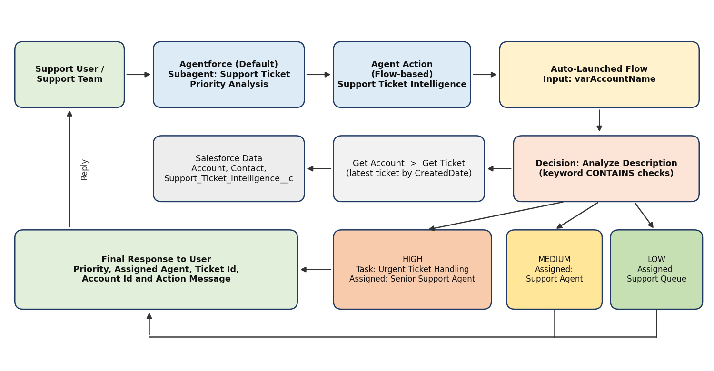
Figure 4.1: Solution architecture

5. Project Planning & Scheduling

5.1 Project Planning
- Agile methodology
- Epics → Stories → Story Points
- Sprint-based execution
- Velocity calculation used for estimation

Product Backlog and Sprint Schedule
Sprint | Epic | USN | User Story / Task | Pts | Priority | Team Member
Sprint-1 | Developer Setup | USN-1 | As a system administrator, I want to configure the Salesforce environment for Support Ticket Intelligence so that the support automation solution can be developed. | 3 | High | Madhupriya P
Sprint-2 | Data Modeling | USN-2 | As an admin, I want to create the Support Ticket Intelligence object with required fields and relationships so that customer support ticket information is stored systematically. | 5 | High | Nithya Darshini E
Sprint-2 | Data Modeling | USN-3 | As a support user, I want support tickets to be associated with Accounts and Contacts so that the latest customer ticket can be identified for analysis. | 3 | High | Sasmitha Ap
Sprint-3 | Automation | USN-4 | As a support agent, I want an Auto-Launched Flow to retrieve the latest ticket and analyze its description so that ticket priority can be determined automatically. | 5 | High | Nivetha V
Sprint-3 | Automation | USN-5 | As a support agent, I want tickets to be automatically classified as High, Medium, or Low based on configured urgency conditions so that critical issues receive attention first. | 5 | High | Nivetha V
Sprint-4 | Agentforce & Automation | USN-6 | As an AI Agent (Agentforce), I want to analyze support ticket details and trigger the backend Flow so that manual ticket prioritization is reduced. | 8 | High | Madhupriya P
Sprint-4 | Task & Assignment | USN-7 | As a support manager, I want High-priority tickets to automatically create an urgent handling task and assign the appropriate support level so that critical tickets are handled quickly. | 5 | High | Nithya Darshini E
Sprint-5 | Agentforce & Conversational Support | USN-9 | As a support user, I want to provide an Account Name to Agentforce and receive the ticket ID, priority, assigned agent, and action message so that I can understand the ticket handling outcome conversationally. | 5 | Medium | Nivetha V
Sprint-6* | SLA Management | USN-8 | As a support manager, I want the system to check SLA breach risk for older unresolved tickets so that potential SLA issues can be identified. (*Planned: optional, moved to future scope.) | 5 | Medium | Sasmitha Ap

Project Tracker and Velocity
Sprint | Total Story Points | Duration | Sprint Start | Sprint End (Planned) | Points Completed | Release Date (Actual)
Sprint-1 | 3 | 3 Days | 17 Sep 2026 | 19 Sep 2026 | 3 | 19 Sep 2026
Sprint-2 | 8 | 3 Days | 20 Sep 2026 | 22 Sep 2026 | 8 | 22 Sep 2026
Sprint-3 | 10 | 3 Days | 23 Sep 2026 | 25 Sep 2026 | 10 | 25 Sep 2026
Sprint-4 | 13 | 3 Days | 26 Sep 2026 | 28 Sep 2026 | 13 | 28 Sep 2026
Sprint-5 | 5 | 3 Days | 29 Sep 2026 | 01 Oct 2026 | 5 | 01 Oct 2026
Sprint-6 (planned) | 5 | n/a | n/a | n/a | 0 | Deferred (future scope)

Velocity: 39 story points were completed across 5 sprints, so the average velocity is 39 / 5 = 7.8 story points per sprint. The remaining 5 points (USN-8, optional SLA check) are planned for a later sprint.
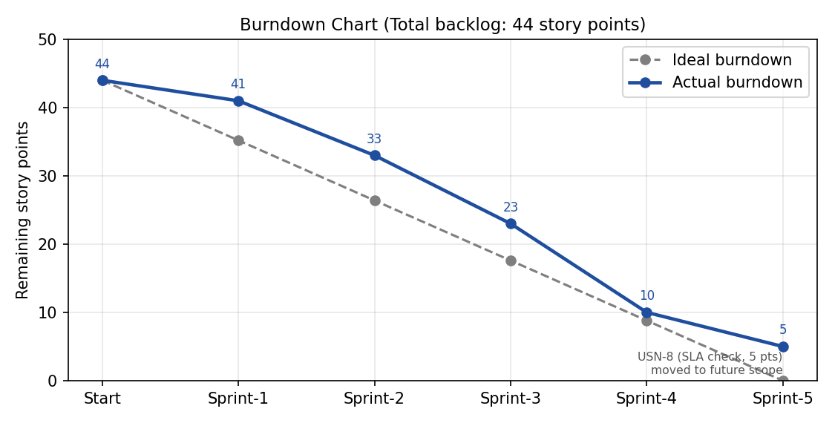
Figure 5.1: Burndown chart

6. Project Development Phase
Concepts used: data modelling, fields and relationships, Lightning record pages, Salesforce Flow (Auto-Launched), and Agentforce subagents with flow-based actions.

Milestone 1: Salesforce Account

Activity 1: Creating a Developer Account
- Open https://developer.salesforce.com/signup.
- Enter first and last name, email, Role = Developer, Company = college name, Country = India, postal code and a unique username in email format.
- Click Sign me up.

Activity 2: Account Activation
- Open the verification email and click Verify Account.
- Set a password and security question, then click Change Password.
- Salesforce redirects to the Setup home page.
[Insert screenshot: Salesforce Setup home page after account activation]

Milestone 2: Data Management – Objects
Custom object: Support Ticket Intelligence. API name: Support_Ticket_Intelligence__c. The record name is an Auto Number (TKT-{0000}). Allow Reports, Allow Activities and Allow Search are enabled so that Tasks can be linked to tickets.
Field Label | API Name | Data Type | Description
Ticket Number | Name | Auto Number | TKT-{0000}
Customer | Customer__c | Lookup (Account) | Related Account
Contact | Contact__c | Lookup (Contact) | Customer contact
Issue Type | Issue_Type__c | Picklist | Technical, Billing, General
Description | Description__c | Long Text Area (32768) | Issue details
Priority Level | Priority_Level__c | Picklist | Low, Medium, High
Status | Status__c | Picklist | New, In Progress, Resolved
Created Date | Created_Date__c | Date | Ticket date
Assigned To | Assigned_To__c | Lookup (User) | Support agent
SLA Breach Risk | SLA_Breach_Risk__c | Checkbox | Risk flag
Resolution Time | Resolution_Time__c | Number (18, 0) | Time taken (hrs)
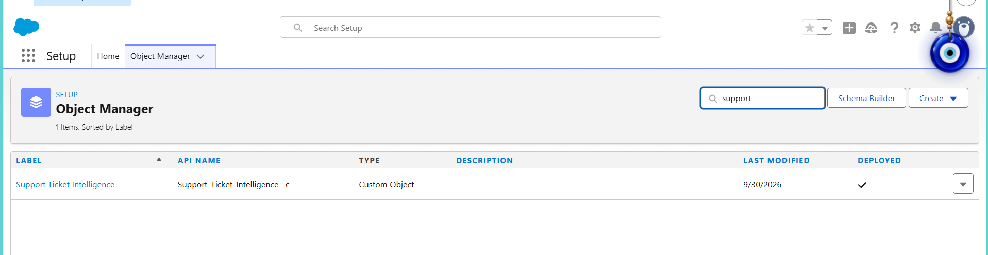
Figure 6.1: Custom object created in Object Manager
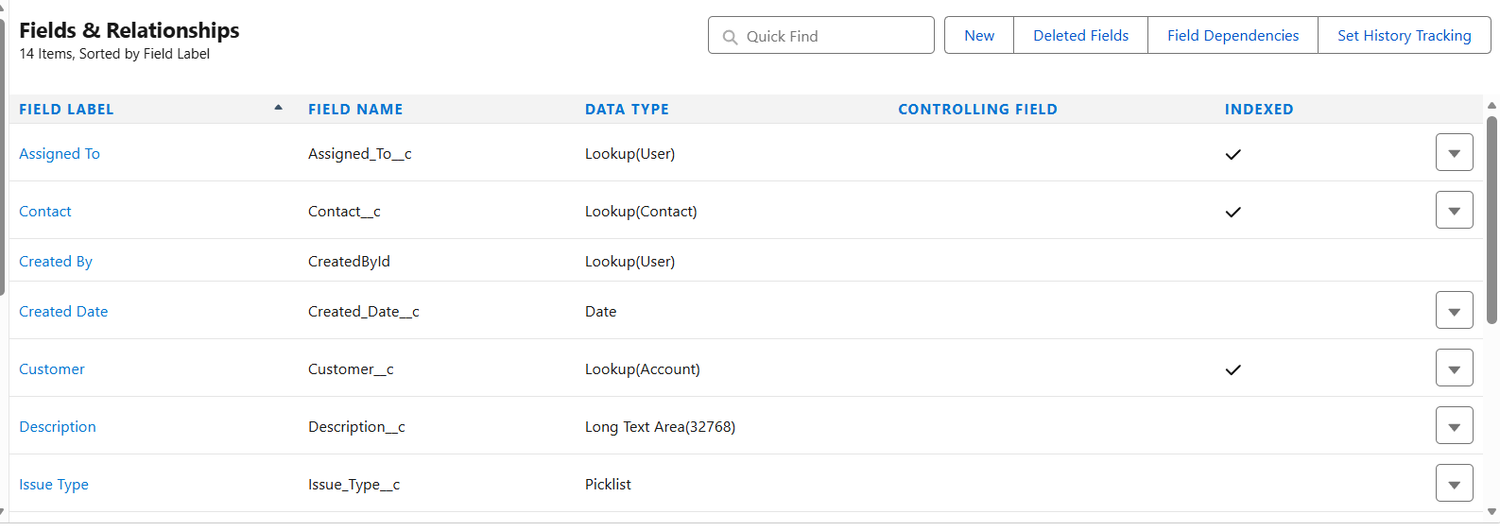
Figure 6.2: Fields and Relationships (part 1)
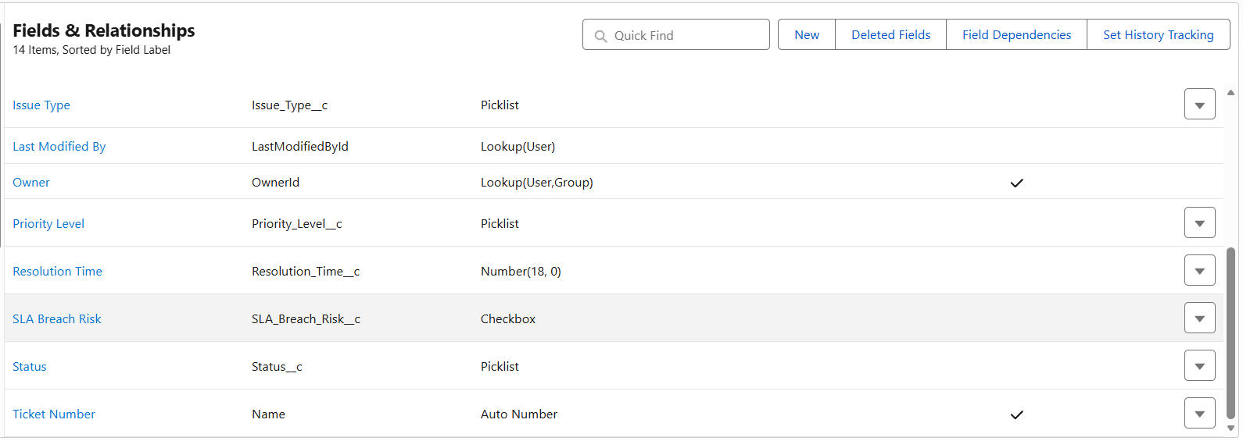
Figure 6.3: Fields and Relationships (part 2)

Milestone 3: Sample Data
Three Accounts (abc, Abdul and XYZ Corp) were created with one Contact each, followed by three support tickets whose descriptions are designed to produce High, Medium and Low priority.
Account | Contact | Ticket | Description | Expected priority
abc | Madhu priya | TKT-0001 | Urgent, system not working | High
Abdul | Abdul Rahaman | TKT-0002 | Dashboard is slow | Medium
XYZ Corp | Ravi Kumar | TKT-0003 | Need help updating my profile | Low
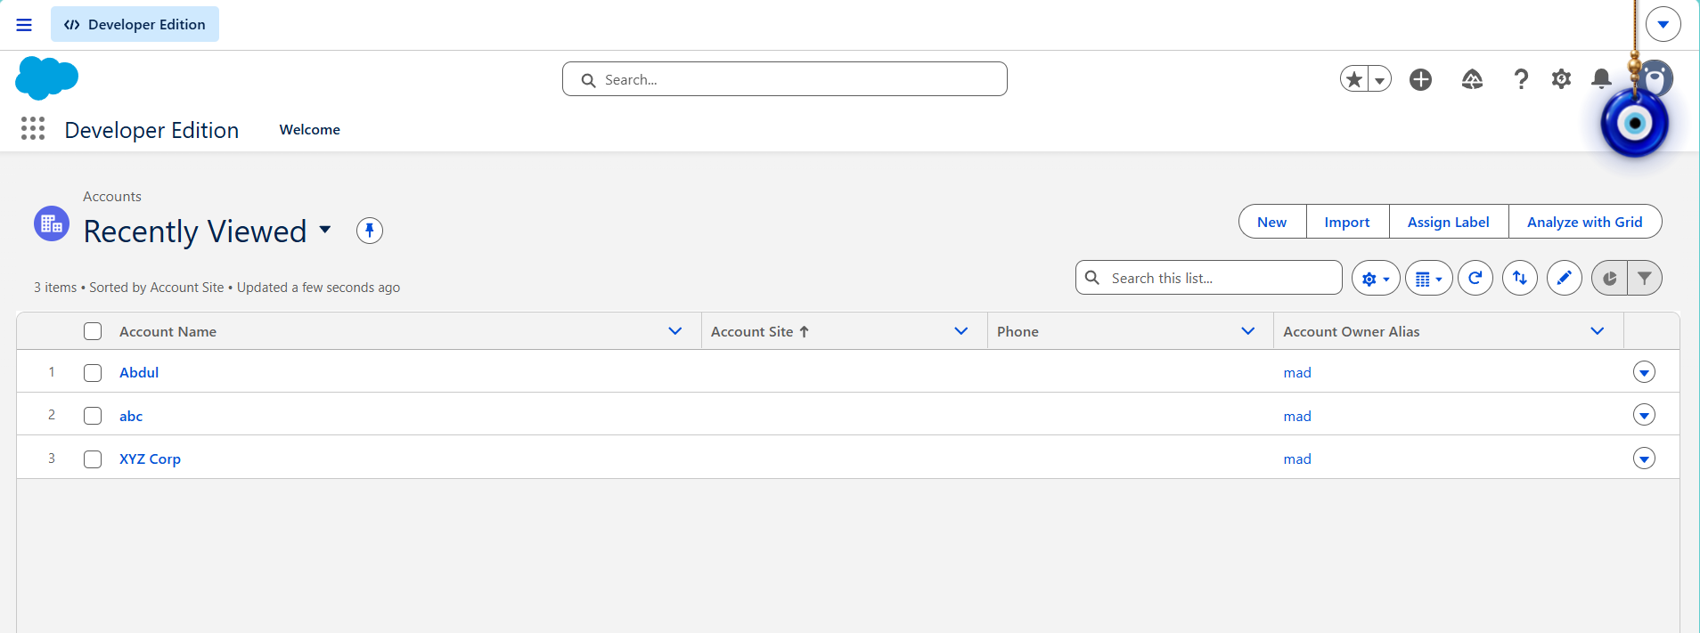
Figure 6.4: Accounts created
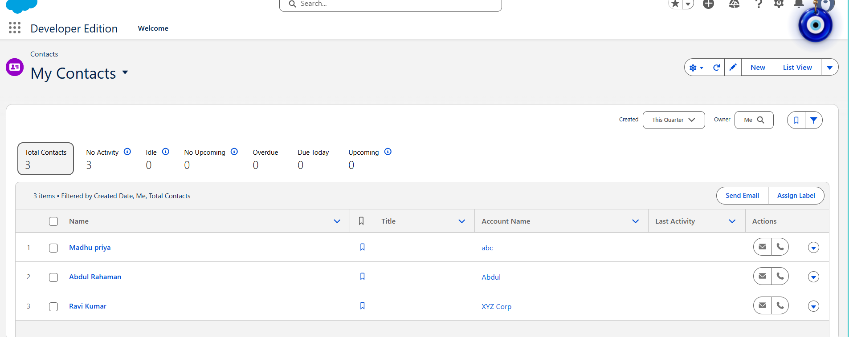
Figure 6.5: Contacts linked to their Accounts

Milestone 4: Auto-Launched Flow
Flow type: Autolaunched Flow (No Trigger), called from Agentforce. Flow name: Support Ticket Intelligence.
Label | API Name | Type | Direction
Account Name | varAccountName | Text | Input
Account Id | varAccountId | Text | Output
Ticket Id | varTicketId | Text | Output
Priority Level | varPriorityLevel | Text | Output
Assigned Agent | varAssignedTo | Text | Output
Action Message | varActionMessage | Text | Output

Flow logic:
- Get Account: Get Records on Account where Account Name equals varAccountName (sorted by CreatedDate descending, first record only).
- Acc Name: Assignment, varAccountId = Account Id.
- Get Ticket: Get Records on Support_Ticket_Intelligence__c where Customer equals varAccountId (latest record only).
- Store Ticket Id: Assignment, varTicketId = Ticket Id.
- Analyze Description: Decision with three outcomes. High Priority: Description contains "urgent", "not working" or "failure". Medium Priority: contains "issue", "slow" or "delay". Default outcome: Low Priority.
- High path: set priority High, create the Task "Urgent Ticket Handling" (WhatId = ticket, Priority High, Status Not Started), assign "Senior Support Agent" and set the urgent message.
- Medium path: set priority Medium, assign "Support Agent" and set the medium message.
- Low path: set priority Low, assign "Support Queue" and set the low message.
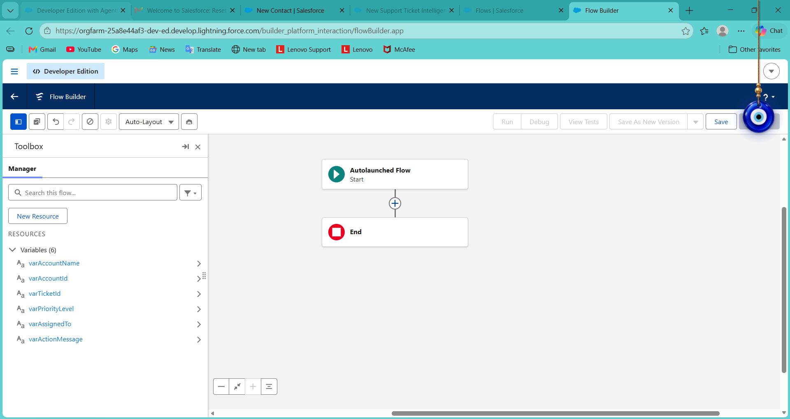
Figure 6.6: Flow variables
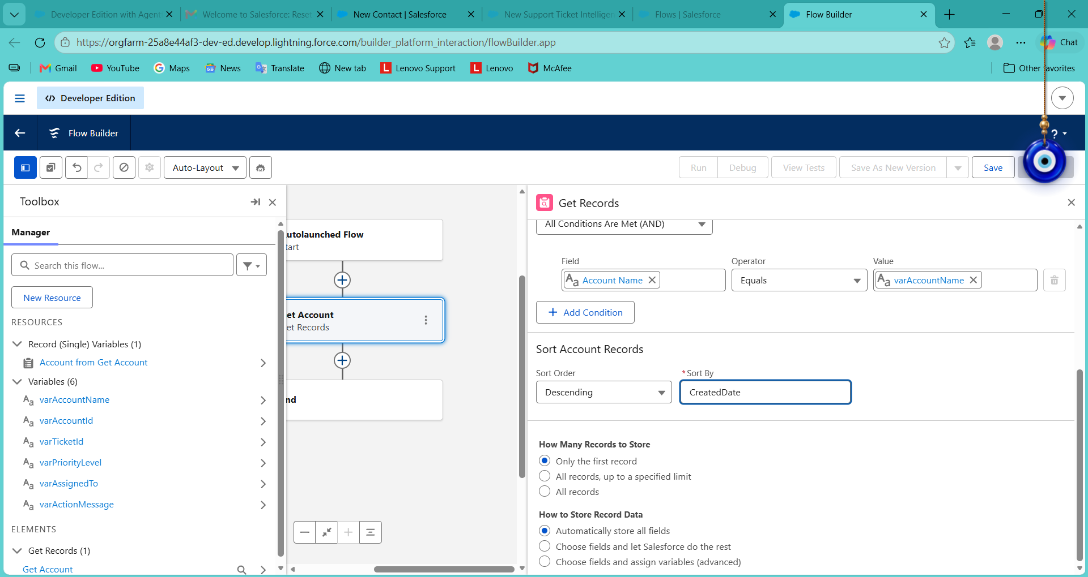
Figure 6.7: Get Account element configuration
[Insert screenshot: complete flow canvas showing all three branches (zoom out in Flow Builder)]
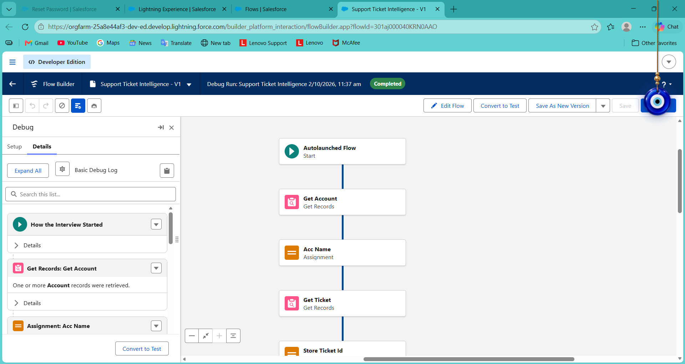
Figure 6.8: Flow debug run completed
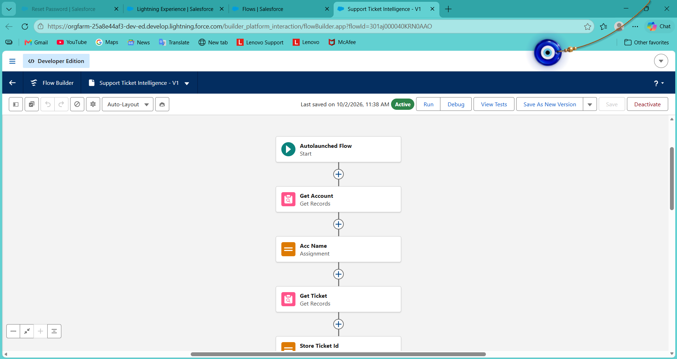
Figure 6.9: Flow in Active status

Milestone 5: Agentforce Configuration
- Enable Agentforce through Salesforce Go (Agentforce (Default), Get Started, Turn On, Confirm) and turn Agentforce on under Setup, Agentforce Agents.
- Open Agentforce (Default) in the Agentforce Builder.
- Create a new subagent with the details below.
- Add the flow as a flow-based agent action and configure its input and outputs.
- Save and activate the agent.

Setting | Value
Subagent name | Support Ticket Priority Analysis
API name | Support_Ticket_Priority_Analysis
Classification description | Analyzes customer support tickets to determine priority based on issue description and urgency. Handles user requests related to ticket status, issue severity and support prioritization.
Scope | Only analyze support ticket descriptions, determine the priority level (High, Medium, Low) and trigger backend automation for task assignment. Do not handle unrelated requests such as billing, subscription management or account updates.
Instructions | Ask for the Account Name; retrieve the latest ticket; analyze the description using keywords; set priority; for High priority trigger the Flow and ensure a task is created; assign the support level; return a clear response (High: urgent handling initiated, Medium: handled shortly, Low: queued); do not update records directly or send emails, use Flow for all actions.
Agent action | Reference type Flow, referencing the Support Ticket Intelligence flow. Loading text: "Analyzing ticket details and determining priority..."
Input | varAccountName (Require Input and Collect Data From User enabled)
Outputs | varAccountId, varActionMessage, varAssignedTo, varPriorityLevel, varTicketId (Show in Conversation enabled, rendered as Text)
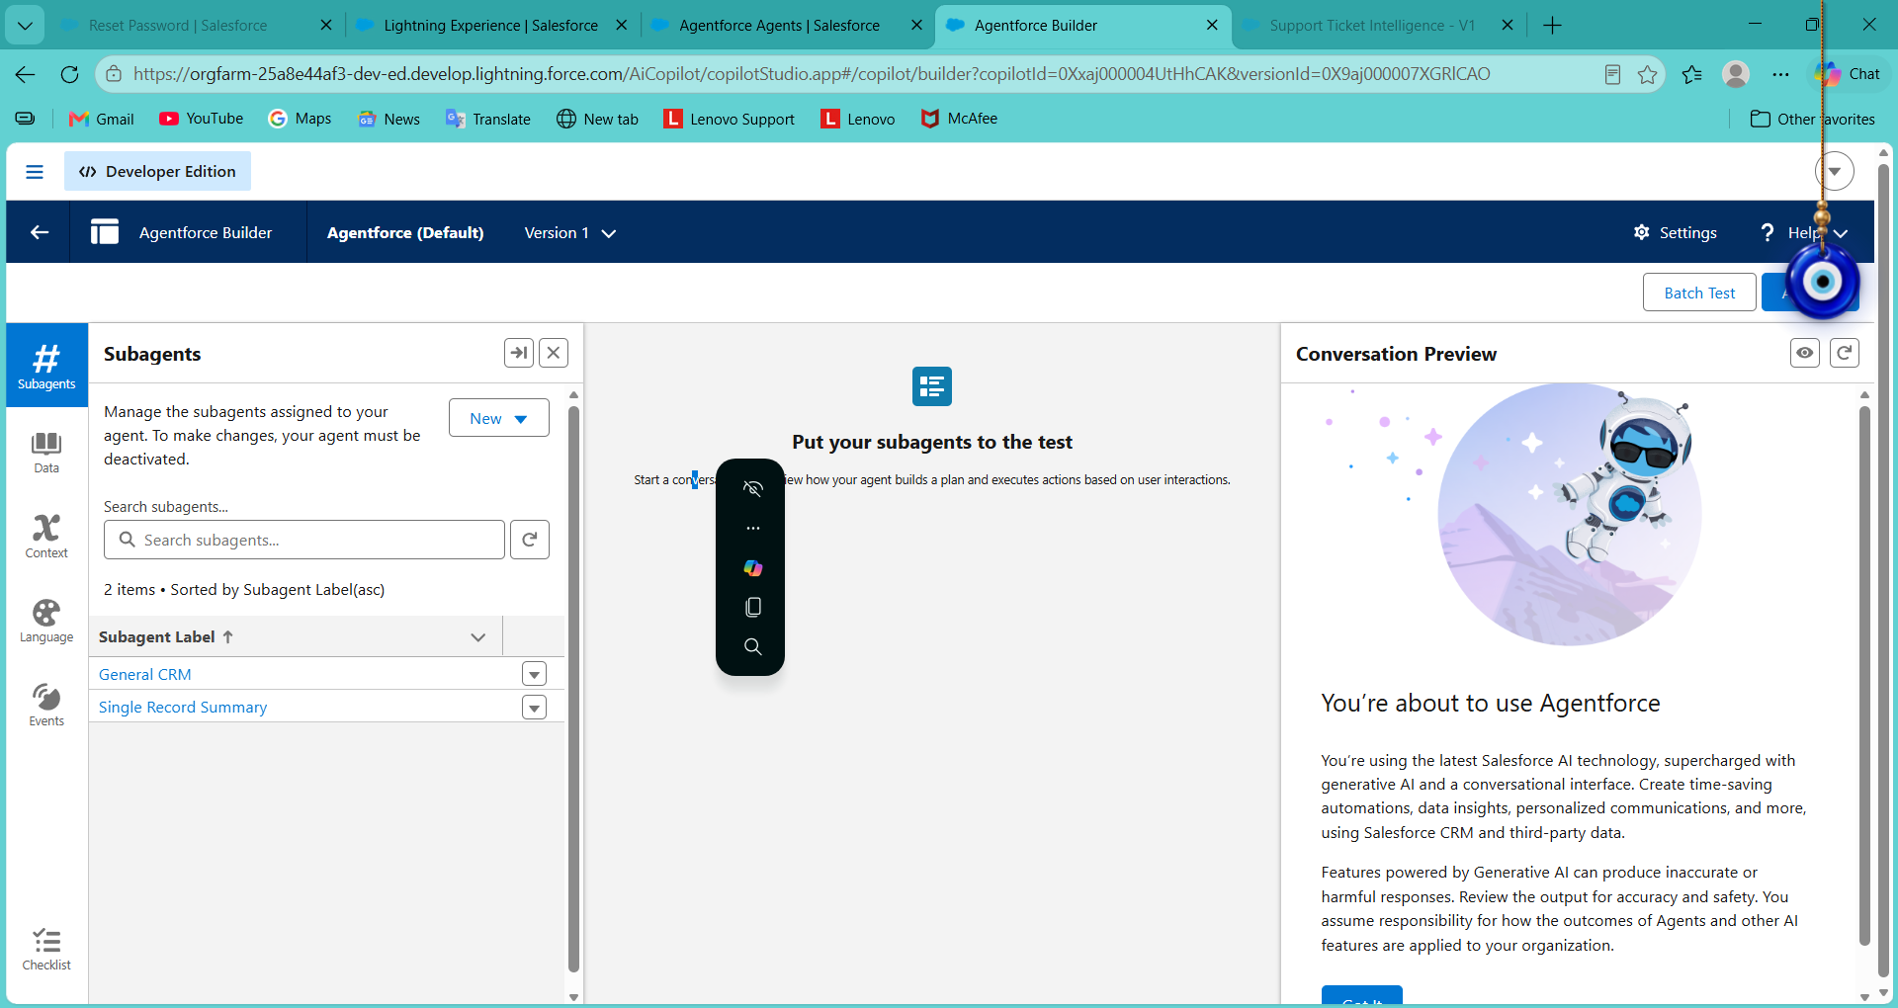
Figure 6.10: Support Ticket Priority Analysis subagent added to Agentforce (Default)
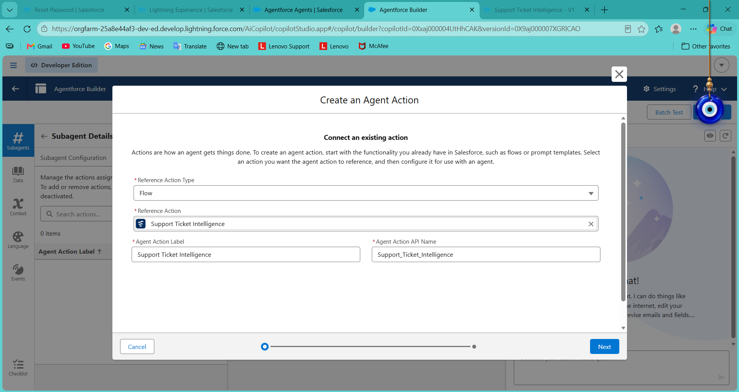
Figure 6.11: Flow-based agent action being created
[Insert screenshot: agent action configuration showing the input and the five outputs]

Milestone 6: Final Output
The agent asks for the Account Name, runs the flow action and returns the account Id, action message, assigned agent, priority and ticket Id. The three tests below show the High, Medium and Low results.
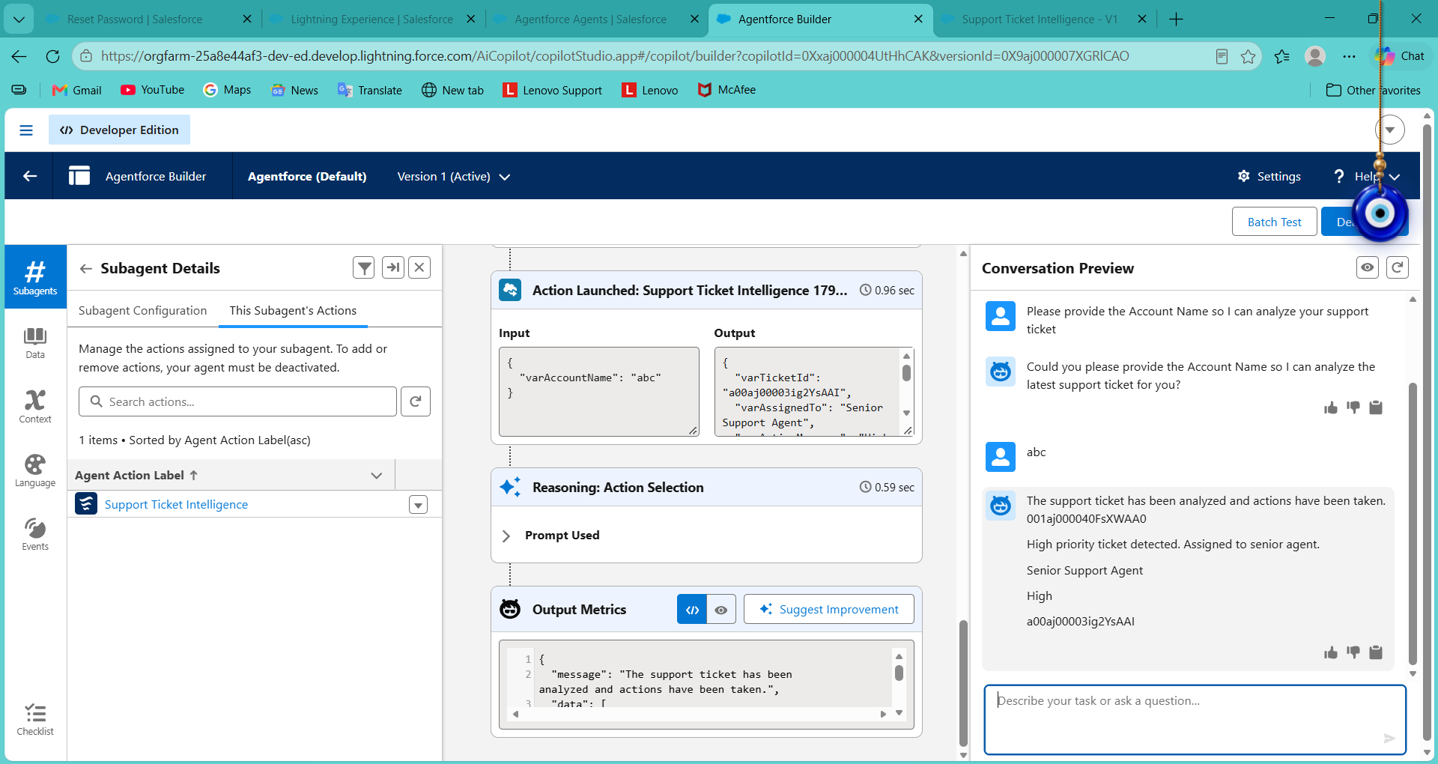
Figure 6.12: Account abc returns High priority, Senior Support Agent
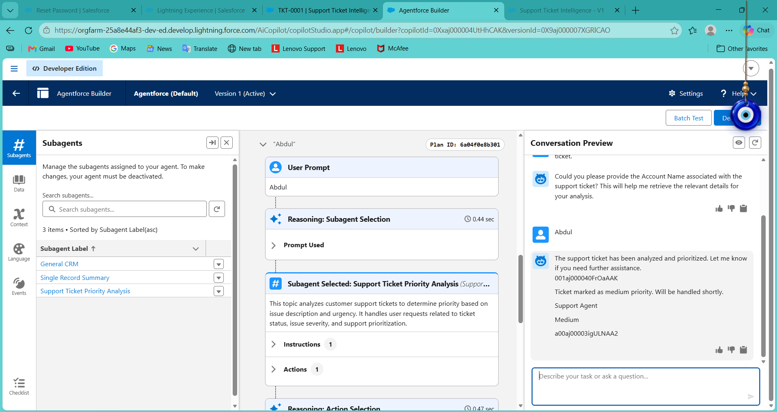
Figure 6.13: Account Abdul returns Medium priority, Support Agent
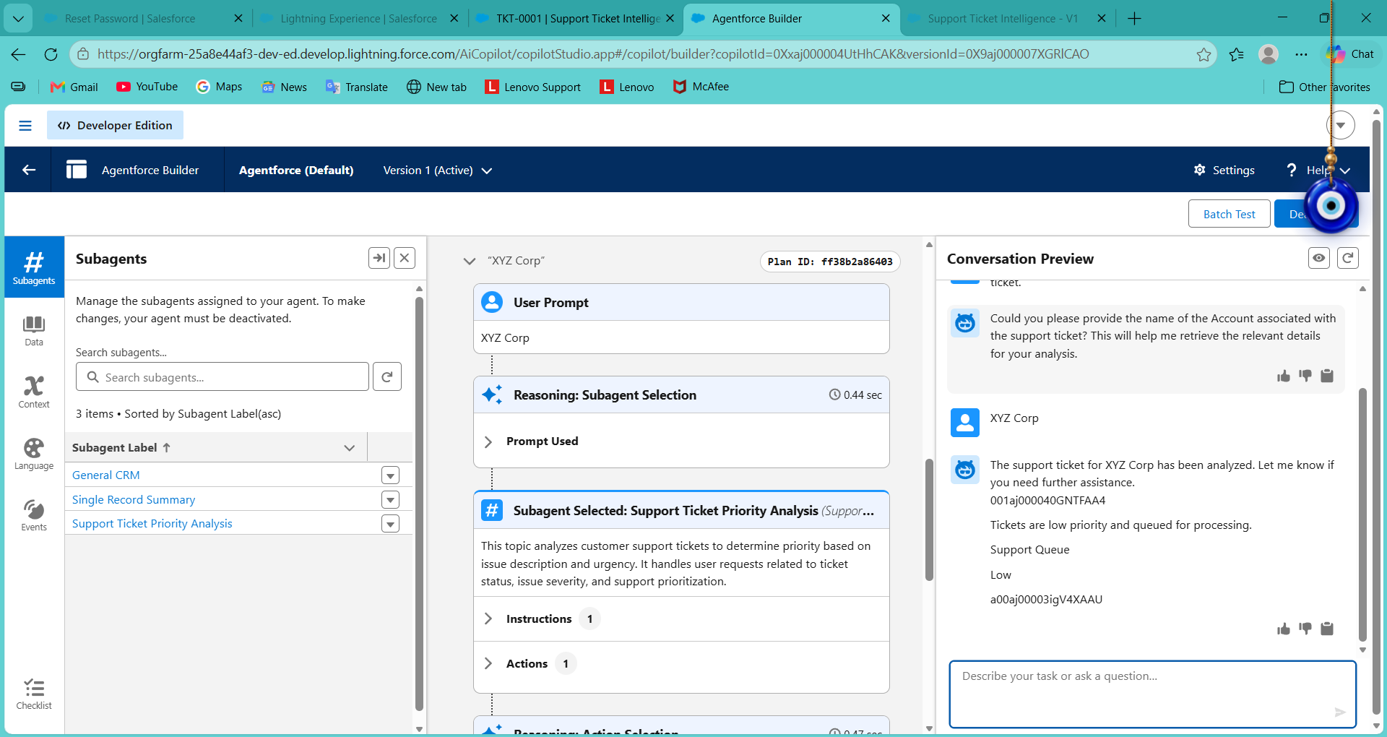
Figure 6.14: Account XYZ Corp returns Low priority, Support Queue
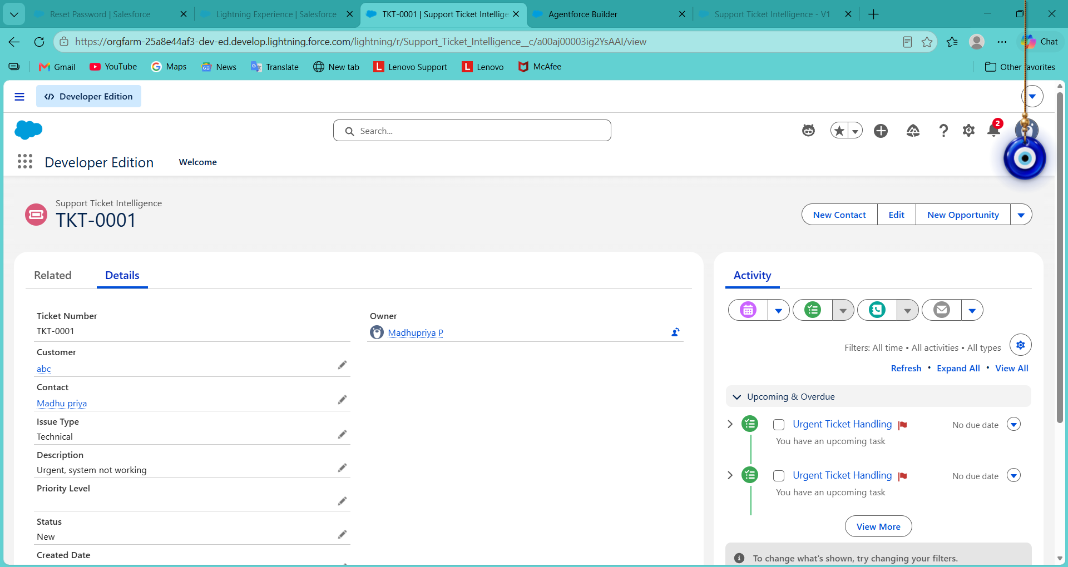
Figure 6.15: Ticket TKT-0001 with the Urgent Ticket Handling task created by the Flow

7. Functional & Performance Testing

7.1 Functional Test Cases
TC | Scenario | Input / steps | Expected result | Actual result | Status
TC-01 | Custom object creation | Create Support_Ticket_Intelligence__c with Auto Number TKT-{0000} | Object listed in Object Manager | Object created and deployed | Pass
TC-02 | Field creation | Create the 10 custom fields | Fields listed with correct API names and types | All fields present (Figures 6.2, 6.3) | Pass
TC-03 | Account and Contact association | Create 3 Accounts with Contacts | Each Contact linked to its Account | Contacts linked correctly | Pass
TC-04 | Ticket records | Create tickets TKT-0001 to TKT-0003 | Tickets linked to Customer and Contact | Tickets stored correctly | Pass
TC-05 | Flow debug run | Debug with Account Name abc | Flow completes without error | Debug run Completed | Pass
TC-06 | Flow activation | Activate the flow | Status shows Active | Flow Active | Pass
TC-07 | High priority | Agentforce: abc ("Urgent, system not working") | High, Senior Support Agent, urgent message | High, Senior Support Agent, "High priority ticket detected. Assigned to senior agent." | Pass
TC-08 | Urgent task creation | High-priority run | Task "Urgent Ticket Handling" on the ticket | Task visible in Activity of TKT-0001 | Pass
TC-09 | Medium priority | Agentforce: Abdul ("Dashboard is slow") | Medium, Support Agent, medium message | Medium, Support Agent, "Ticket marked as medium priority. Will be handled shortly." | Pass
TC-10 | Low priority | Agentforce: XYZ Corp ("Need help updating my profile") | Low, Support Queue, low message | Low, Support Queue, "Tickets are low priority and queued for processing." | Pass
TC-11 | Conversational input | Ask for ticket analysis without an Account Name | Agent asks for the Account Name | Agent requested the Account Name | Pass
TC-12 | Subagent routing | Support-ticket request | Support Ticket Priority Analysis subagent selected | Subagent selected (shown in the reasoning trace) | Pass

7.2 Performance Observations
- Agentforce Builder reasoning trace: subagent selection took about 0.44 seconds.
- The flow-based action completed in about 0.96 seconds for Account abc.
- The latest ticket is retrieved with one indexed lookup on Customer__c, so retrieval time does not depend on the number of keywords checked.

7.3 Issues Encountered and Resolutions
Issue | Resolution
Create Records asked for a record variable | Changed "How to set record field values" to "Use separate resources, and literal values" and set Task fields individually.
Decision showed the error "Conditions must include operators" | An extra empty outcome (Outcome 3) had been added; it was deleted.
Agent action API name already in use | Used a unique API name for the action.
Activation warnings (overlapping subagents, Data Cloud not enabled) | Informational for a Developer Edition org; the agent was activated with Ignore & Activate.
Unsaved flow changes lost after closing the browser | Reopened the saved flow and rebuilt the missing elements, saving after each element.

8. Advantages & Disadvantages

Advantages
- Automatic ticket prioritization: classifies tickets as High, Medium or Low from the description.
- Faster identification of critical issues: helps support agents focus on urgent tickets first.
- Reduced manual effort: automates analysis, priority setting, task creation and assignment.
- Intelligent ticket handling: Agentforce analyzes ticket details and starts the backend automation.
- Automatic urgent task creation: High-priority tickets create an Urgent Ticket Handling task.
- Improved support assignment: High-priority tickets go to a senior support agent.
- Conversational support: users interact with Agentforce and receive the outcome in the chat.
- Better response time and scalability: Salesforce automation supports growing ticket volumes.

Disadvantages
- Keyword-based priority logic: classification depends on configured keywords (urgent, not working, failure, issue, slow, delay).
- Limited context understanding: other urgency signals may be missed.
- Dependence on accurate data: correct Account and ticket data are required.
- Flow and Agentforce configuration dependency: changes need maintenance of the Flow and subagent.
- Limited Agentforce scope: unrelated requests such as billing are out of scope.
- SLA monitoring is limited: the SLA check is optional and not part of the tested flow.
- Assignment logic is simple: support level is a fixed label rather than a real User assignment.
- Priority is returned, not stored: the flow returns the priority to Agentforce but does not update the Priority Level field on the record.

9. Conclusion
The Customer Support Ticket Priority Prediction and Automated Assignment System demonstrates how Salesforce Flow and Agentforce can work together to reduce manual support-ticket handling. The solution retrieves the latest ticket for an Account, analyzes its description, classifies priority, creates an urgent task for High-priority cases, assigns a support level and returns a clear conversational response. Testing with three accounts confirmed the correct High, Medium and Low outcomes, and the urgent task was created for the High-priority ticket. This supports faster ticket handling, reduced manual effort, intelligent prioritization and better team productivity.

10. Future Scope
- Add more priority indicators and business rules (for example customer tier or issue type).
- Write the calculated priority and assigned user back to the Priority Level and Assigned To fields.
- Add the SLA decision and more sophisticated SLA monitoring and escalation.
- Support additional support teams and assignment rules, including real User assignment based on workload.
- Send real-time notifications to agents and customers.
- Introduce dashboards for priority trends and resolution performance.
- Extend Agentforce outputs with additional ticket information.

11. Appendix
- A. Custom Object: Support Ticket Intelligence (Support_Ticket_Intelligence__c)
- B. Key Salesforce Records: Account, Contact, User, Task
- C. Flow: Support Ticket Intelligence, Auto-Launched Flow
- D. Agentforce Subagent: Support Ticket Priority Analysis
- E. Agentforce Action: Flow-based Support Ticket Intelligence action

Thank You

